**Modeling Life Expectancy – Jake Skiba**

**Introduction**

One of the biggest areas in life insurance is what information can be gathered through modeling life expectancy, mortality rates, and many other data information. This can be captured for a total population, but also for different races, ages, genders, and even across different years. In this project, after cleaning data in R, my goal was to model some of this data to gather basic information and then shift to an actuarial focus where annuities were priced, where I use Excel to do this modeling and graphing. When gathering conclusions, I wanted to make connections to how life insurance would be priced through an inverse relationship but also tie some verification back through the base models like life expectancy and mortality rate through different races and genders, and what this can mean for pricing annuities and insurance premiums. This information is shown in a dashboard, where a user-friendly interface can explore and change their own factors like race and gender, and then further conclusions will be shown throughout the report.

**Project Design**

Rather than finding just the base information with all the values, I wanted to find a dataset where I can gather and extract values and also clean the data. In my design, I only used the 21st century, more of a short-term modeling and where the data is present/little missing values. I cleaned the data to only include year's 2000 and beyond, to 2021, and then cleaned the data in R to be able to use for modeling.

I brought this data back over to Excel, and then I began to understand the data and what can be relevant to include. To create a user-friendly dashboard, I intended to have separate but relevant sections, which include an overview where a user can view life expectancy, mortality rate, and number survived at each age throughout the years, and slicers to change age, race, and gender. I then created a section of what things can look like at birth or age 0, which modeled each race together to visualize direct comparison between them for life expectancy and mortality rate. I also modeled the impact Covid had in 2020, which shows the mortality rate for key ages before, during, and after the pandemic. Finally, to tie in actuarial work, I created fair pricing for annuities to be bought for after retirement age. I created a direct visualization which shows the present value, or what the annuity would be bought at, for each gender and race. In a separate sheet, I designed a table where a user can change what age the annuity can be bought at, as well as change the demographic settings based on an individual. This will allow easy access to see what the annuity should be priced at for whomever may be looking.

**Results**

After modeling much of what I needed in the dashboard, I was able to visualize trends within life expectancy and other graphs. The first piece was looking at overall population, where since 2000, there was a general increase in life expectancy, until around the Covid era where there shows a big drop. This can signify a potential impact on a certain group, whether it be age or some other demographic factor, to be explored later. 2016 shows a low life expectancy/number surviving at each age, as well as a high mortality rate, which can be due to incomplete/lack of data. After filtering the dataset, there was very little data for 2016, which could show the high variation. Also, 2018 is missing data for each race, and only has data for the total population. While no changes were made as I wanted the true impact to be shown, there is possibilities to average out 2017 and 2019 to assume 2018 values. This year was still included, and in the graphs below, you can see these taking place.

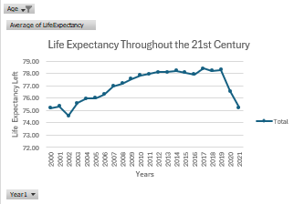*Figure 1.1 Figure 1.2*

Figure 1.1 shows a heavy decrease in life expectancy during Covid, so it is reasonable to believe the impact is significant to model. However, the overall graph shows a general increase in life expectancy over the years, which can indicate future life expectancy to continually increase post-Covid. Figure 1.2 also shows a decrease in mortality rate in the first year, throughout the 21st century. However, for different races, like for blacks, it is higher than other groups. We can see this connection in life expectancy, where they will have lower amounts, and then with annuity pricing as well, where the prices will be cheaper since they are not expected to live as long.

In terms of the Covid impact, we can look through the years right before in 2019, during in 2020, and after in 2021, and look at how the mortality rate increased for different ages and if it is significant. We can filter out race and gender by looking individually at each group to see the impact affected different groups in different ways.

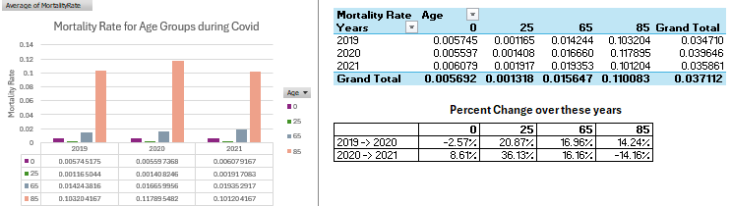

*Figure 1.3*

The precent change allows the easiest visualization to see if Covid impacted mortality, and the graph allows to see what age groups had the highest mortality throughout the years. Every age except for 0 showed Covid increasing their mortality rate significantly, which evidently shows the impact by a good margin. After the first year of Covid, however, all ages except for 85 still saw an increase in mortality. This may be due to better immunity/vaccinations for older ages, but the cause for younger ages to still increase isn’t very obvious, and more research would need to be done to understand why this has happened.

After these basic visualizations, the focus shifted to what these can mean through annuity and insurance pricing, and what connections can be made between them. Using ages 65 and older, where an individual can buy an annuity at any age, I extracted each of their mortality rates. Then, I created a formula to find the probability kp_x, the likelihood of surviving to age x. Using this and a discount rate of 3% to include the time value of money, where over time, the value of the dollar gets less and less (the discount rate assumes 3% per year), I was able to calculate term value, or what the dollar amount at each age is. I assumed a yearly payment of $10,000/year. This is calculated as:

*Term Value = Yearly Payment * pk_x (surviving to age x) * v^x (discount rate)*

The term value calculates at each age, what the value of the payment to them will be at each age depending on its future value (bringing it to present value) and the likelihood of survival at each age. As they get older, there is a higher chance the insurance company will not have to pay out that annuity of $10,000/yr because the person isn’t alive anymore. In a sheet, a user can change the age of buying the annuity and other demographic factors to compare how the price of the annuity changes for these factors. In the graph below, I choose to model just at age 65 and its PV, but the trends follow similarly as each different age bought at changes.

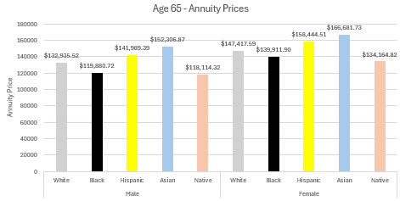

*Figure 1.4*

We can gather a few conclusions here. First, female annuity prices are roughly $15 - 20k more expensive, assuming $10k per year payment, for all races. This will align with mortality rate, where females have a lower mortality rate, therefore a higher chance of surviving to any age. It also corresponds with a higher life expectancy, where because they will potentially live longer, the expected amounts of payments received will be higher, so there is a greater annuity cost. Similar conclusions apply for the races. Asians have the highest annuity price, which implies a higher life expectancy and lower mortality rate at senior ages, and for blacks and Native Americans, the opposite is true. These can be verified through applying filters to graphs above.

Now we can compare this to insurance pricing. The pricing of insurance is essentially the inverse, where the policyholder will be paying monthly, and at their death (since this is life insurance), they will be paid a lump sum. While these aren't shown, we can draw similar, yet inverse, conclusions. First with the gender comparison, a male will be paying a higher insurance premium. The mortality risk at an earlier age compared to females will result in a lower annuity cost but higher insurance premiums. Similarly with races, a race with higher annuity premiums, like the Asian group, will pay lower insurance costs. This is all due to risk management based on the demographic differences and their mortality rate, in which all of these are priced fairly.

I would recommend looking into the dashboard and viewing some of the information, where you can apply certain filters and visualize trends based on demographic factors and ages.

**Conclusions**

Life expectancy and its surrounding factors vary across all demographics of people, and it’s important to understand and model all the differences to accurately predict and provide for the future, whether that be insurance, annuities, or even just future models. As the project developed and dove deeper into an actuarial focus, modeling differences and making connections to things like life expectancy and mortality rates were important to understanding why premiums are priced the way they are. Whether that be certain races having cheaper annuity prices, to the inverse of insurance pricing to annuities, these helped develop the project into gaining more advanced knowledge and understanding of the actuarial field.